SIGHT-SINGING BONUS: For up to 30 points, sight sing one of the excerpts below on any starting note. A mostly correct rendition will receive 30, a rendition where both melodic contour and rhythm are mostly correct or where the melody is mostly correct will receive 20, and a rendition that approximates either the melody or the rhythm will receive 10. 5 points will be deducted for a garbled text.

1. Lyric soprano (sing Poppaea’s line only)
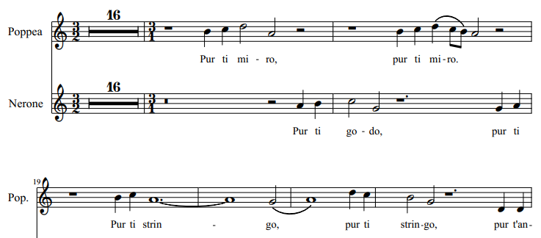

2. Tenor leggiero (sing Italian)
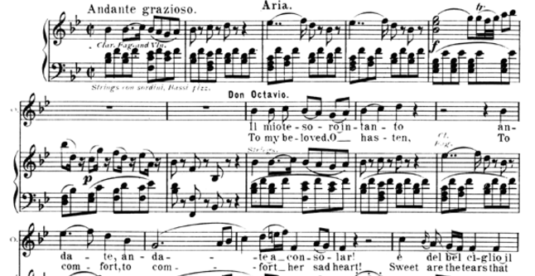

3. Lyric tenor (sing Italian or German)

4. Coloratura contralto
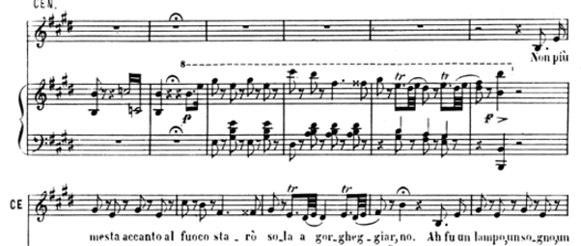

5. Basso cantante (sing 1st verse)
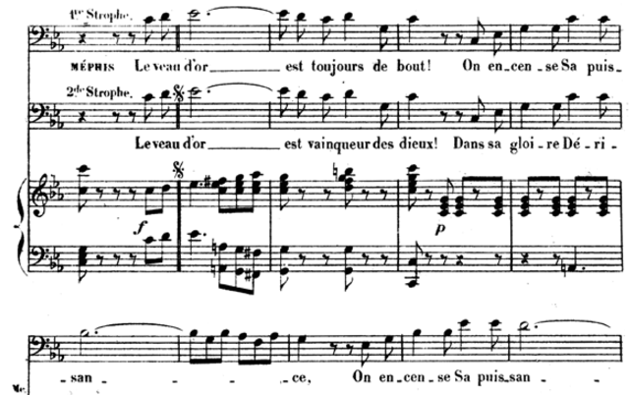

6. Deep contralto (sing German)
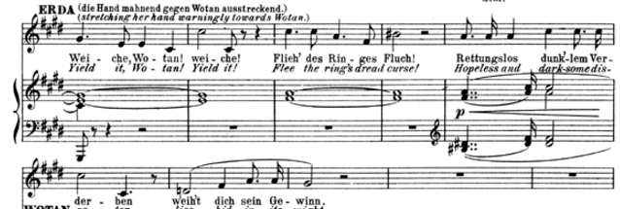
7. Dramatic soprano (I prefer you sing French)
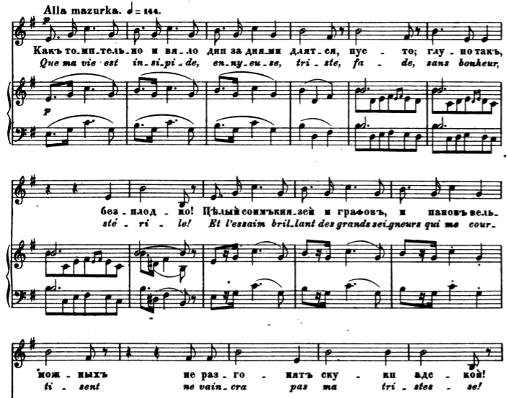

8. Dramatic baritone
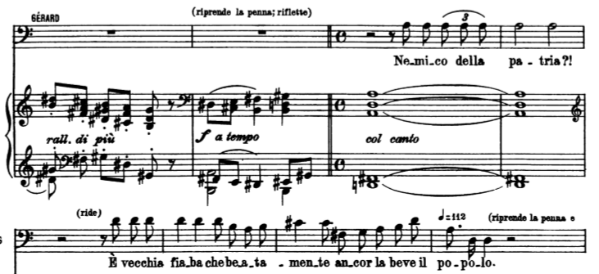

9. Lyric bass
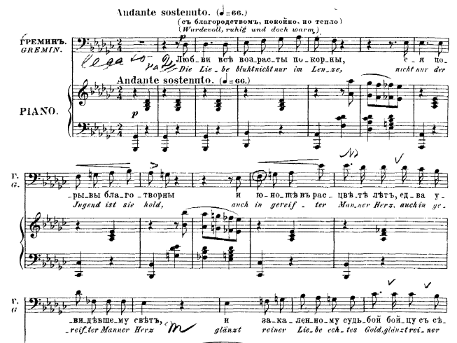
10. Lyric tenor
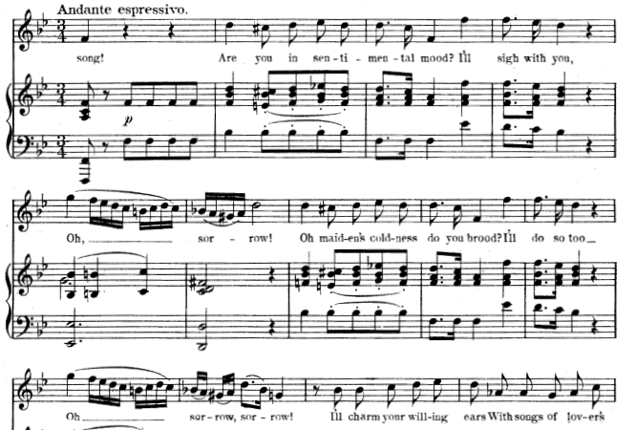
11. Lyric mezzo
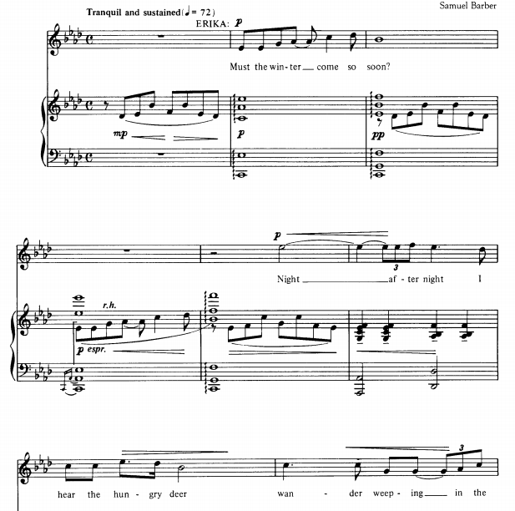

12. Coloratura soprano
